Project Design Phase
Solution Architecture

Date | 29 June 2026
Name | VARSHINI S
Project Name | The Metro Ticket Generating System automates the ServiceNow
Maximum Marks | 4 Marks

Solution Architecture:
Solution architecture is the process of designing a structured and efficient technical solution that bridges business requirements with technology implementation. It defines how different system components interact to provide a reliable, scalable, and user-friendly application. For the Metro Ticket Generating System in ServiceNow, the solution architecture focuses on automating metro ticket booking, fare calculation, QR code generation, and request processing through the ServiceNow platform.
Its goals are to:
- Provides an Automated Ticket Booking Solution: Eliminates manual ticket booking by enabling passengers to book metro tickets online through the ServiceNow Service Portal. The system automates request submission, fare calculation, QR code generation, and booking confirmation.
- Defines System Structure and Data Flow: Presents a clear architecture consisting of the Service Portal → Service Catalog → Flow Designer → Custom Metro Ticket Table → QR Code Generation → User Confirmation, ensuring secure and seamless movement of booking information across the platform.
- Supports Modular and Scalable Development: Organizes the application into independent modules including catalog creation, form validation, automated workflow execution, data storage, and QR code generation, allowing future enhancements such as payment gateway integration, email notifications, and mobile application support.
- Ensures Secure and Reliable Processing: Implements mandatory field validation, automated data mapping, secure record storage, and Flow Designer automation to provide accurate fare calculation, reliable ticket generation, and efficient request processing while maintaining data integrity.

Example - Solution Architecture Diagram:
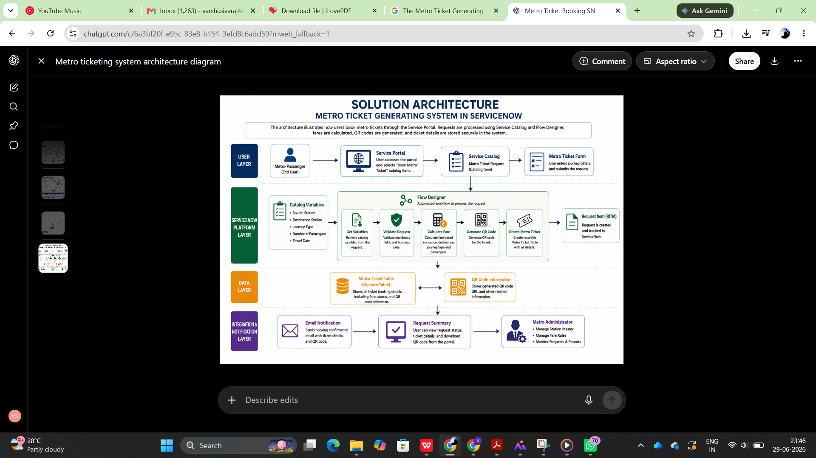

Reference:
• ServiceNow Developer Documentation – Flow Designer and Service Catalog
https://developer.servicenow.com/
• ServiceNow Architecture Documentation
https://docs.servicenow.com/

